**Name: Mriganka Patra**

**Email:** [**Mriganka.patra@cognizant.com**](mailto:Mriganka.patra@cognizant.com)

**Day 9**

**Assignment 2**

Task 1: Configure a role hierarchy and create 3 roles with different access scopes

1. Go to Setup and open the Quick Find box
2. 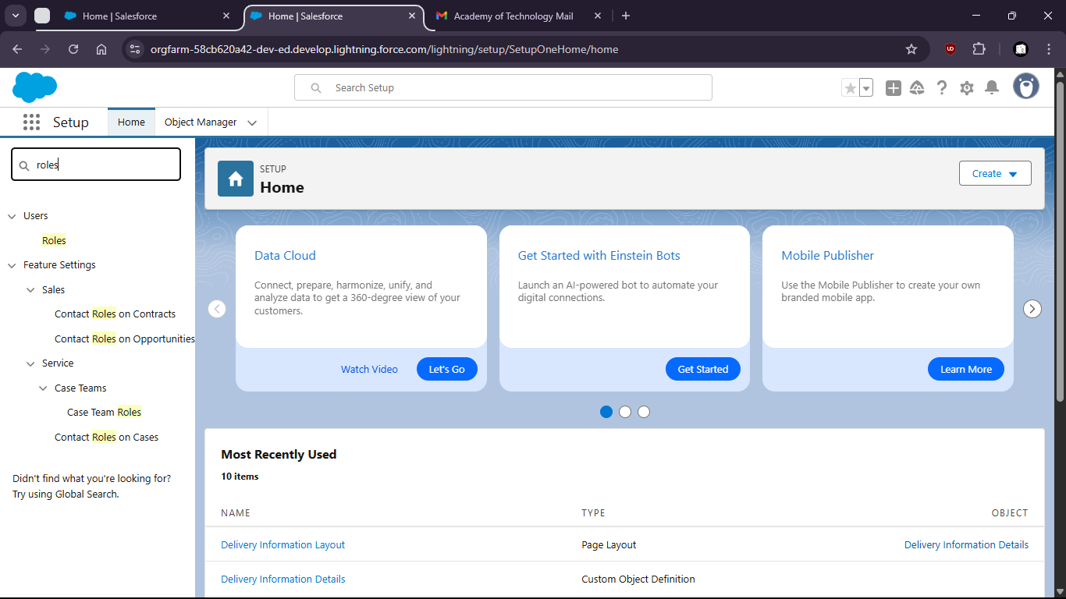
3. Search and open Roles
4. 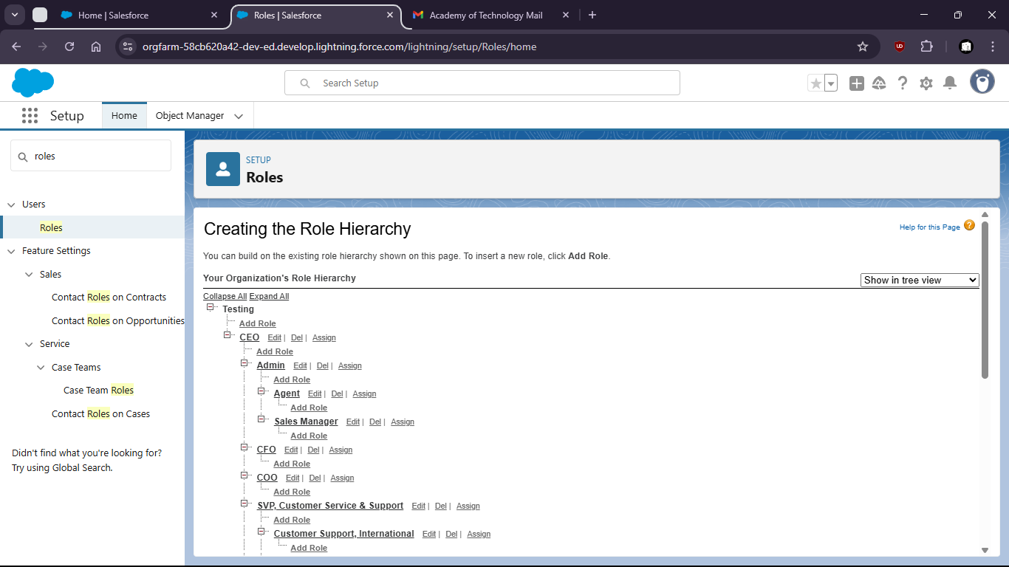
5. Click Setup Roles
6. 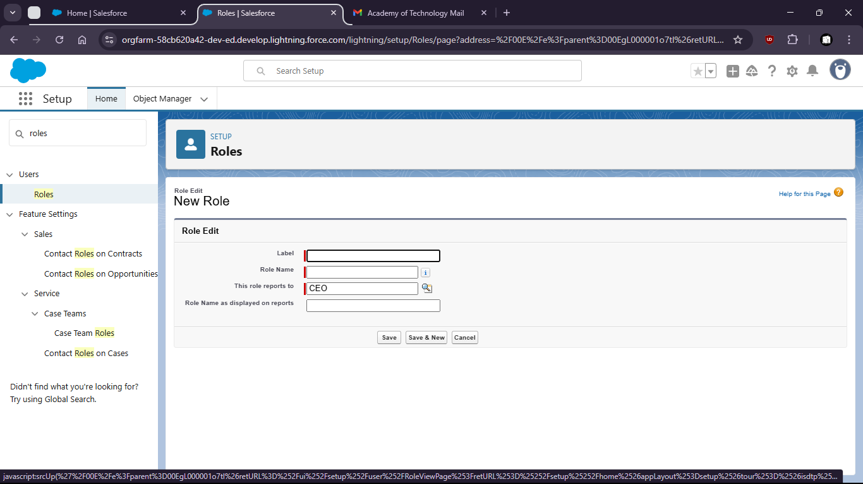
7. Click on add role under CEO
8. 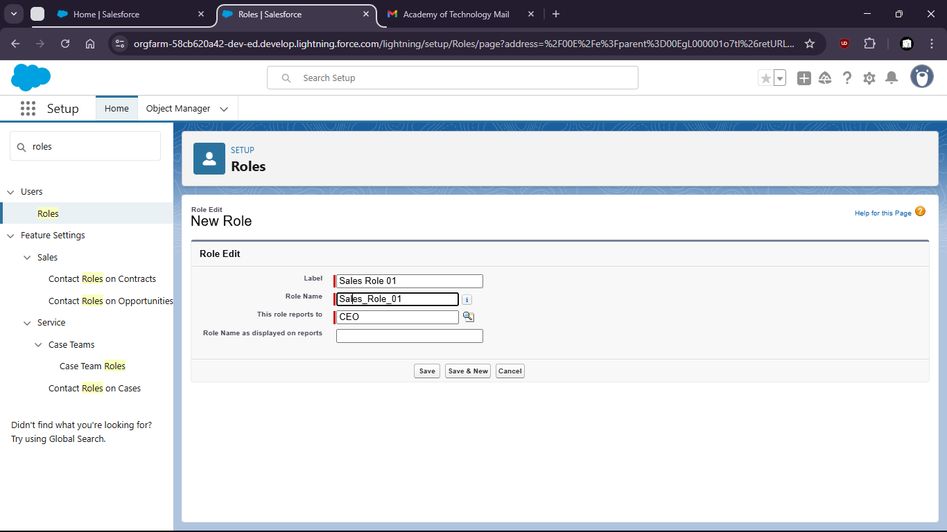
9. Now create 3 roles
10. 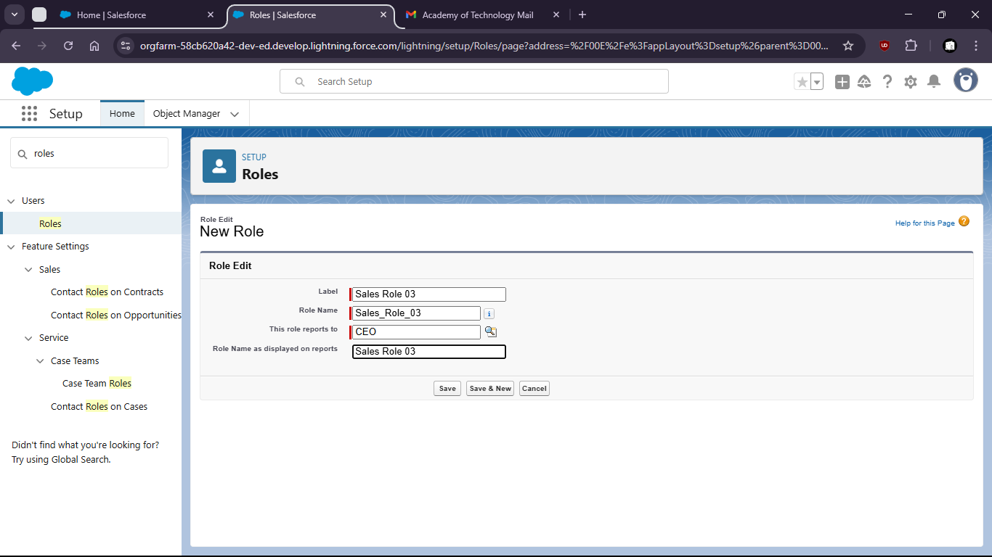

Task 2: Apply sharing rules for a custom object to demonstrate row-level security.

1. Go to Object Manager
2. 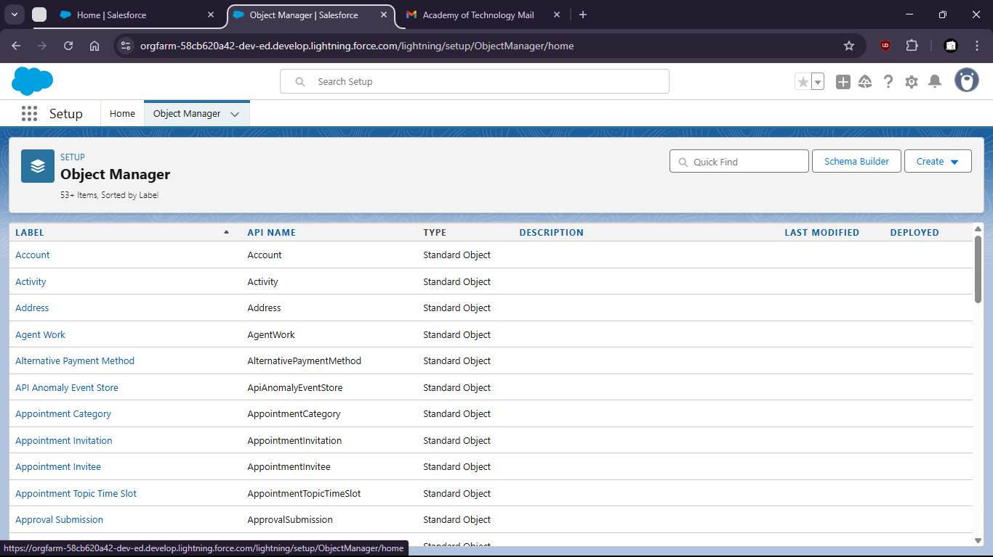
3. Click on Create > Custom Object
4. 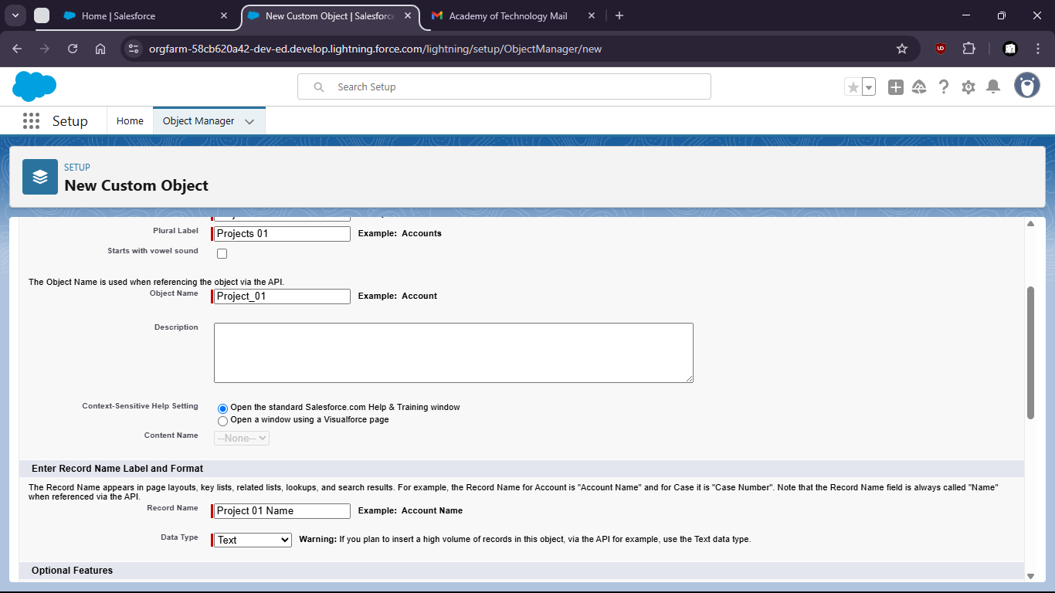
5. Go to Sharing Settings
6. 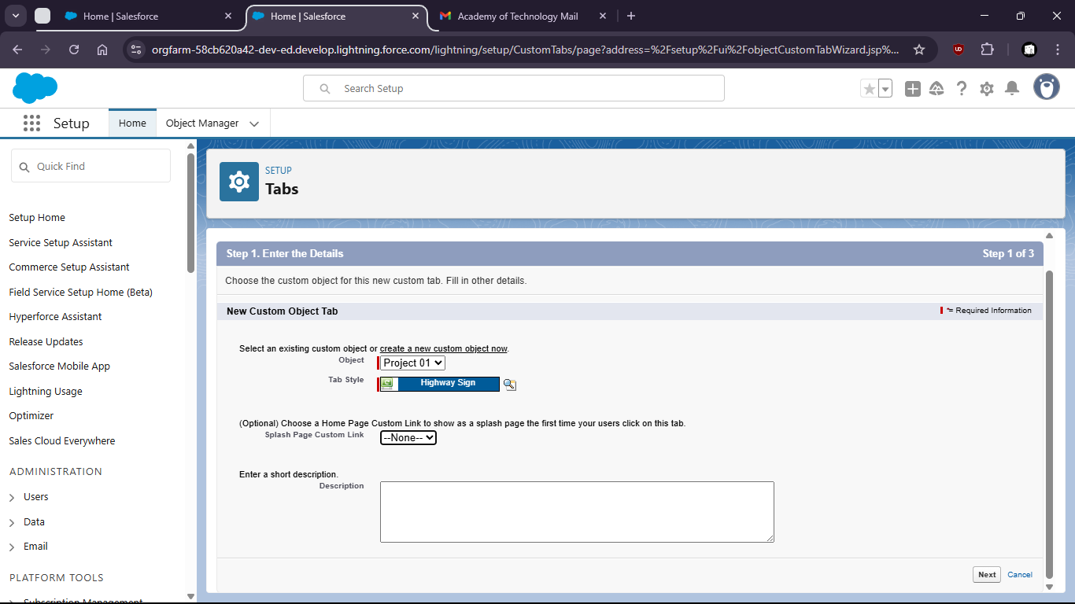
7. 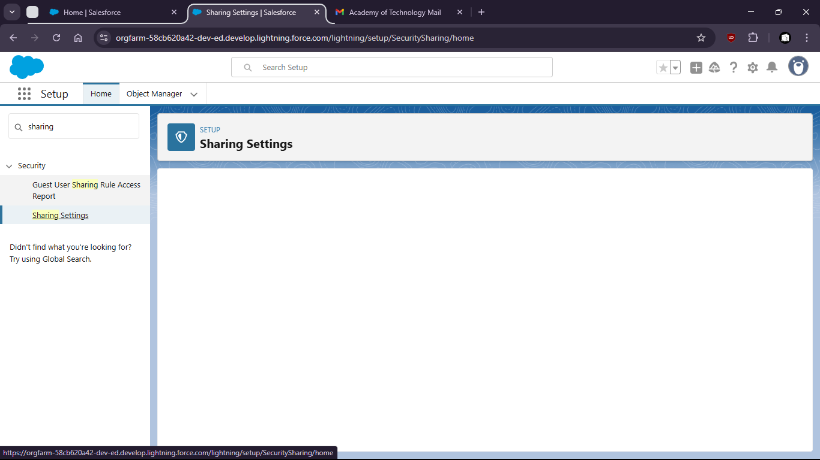
8. Set default internal access to Private
9. 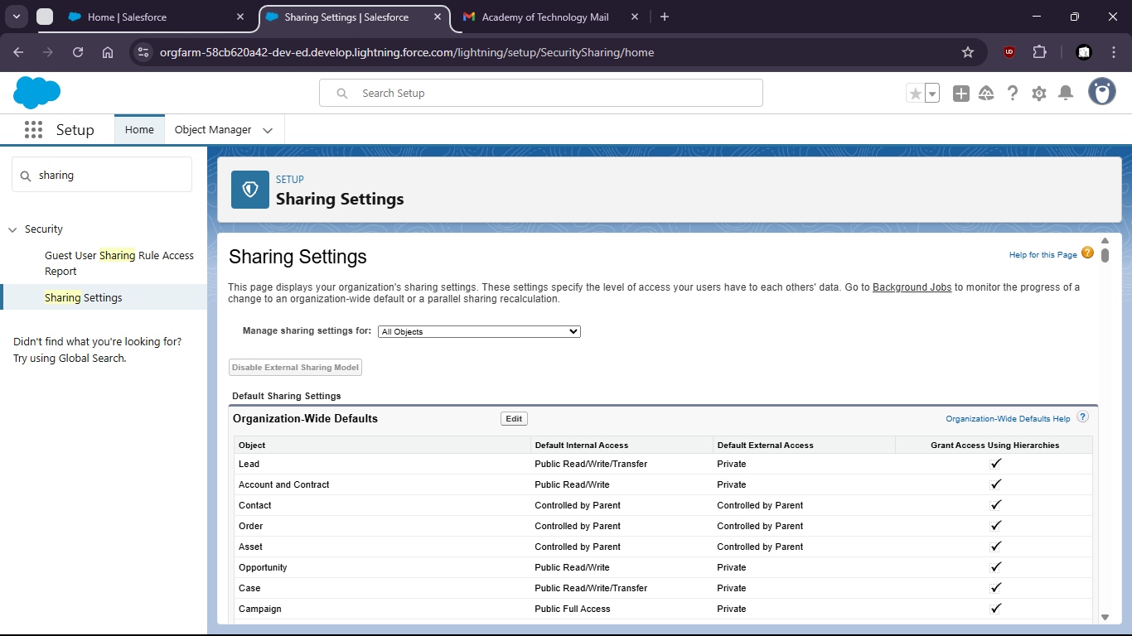
10. Scroll to Sharing rules and click new
11. 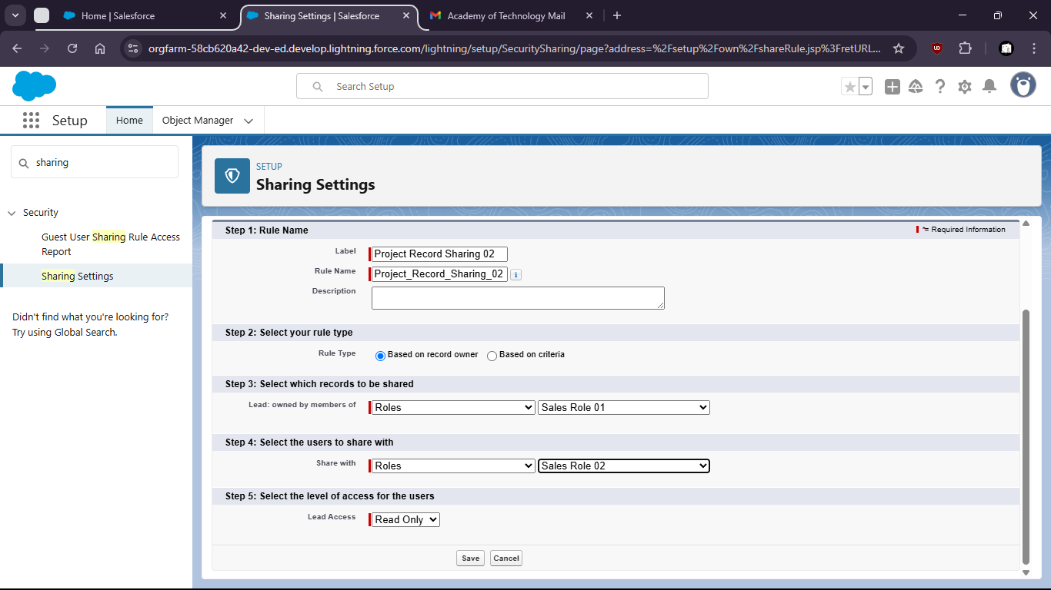

Task 3: Set field-level visibility restrictions for specific profiles (eg: hide revenue field for ‘Intern’ profile)

1. Goto Setup > Profiles
2. 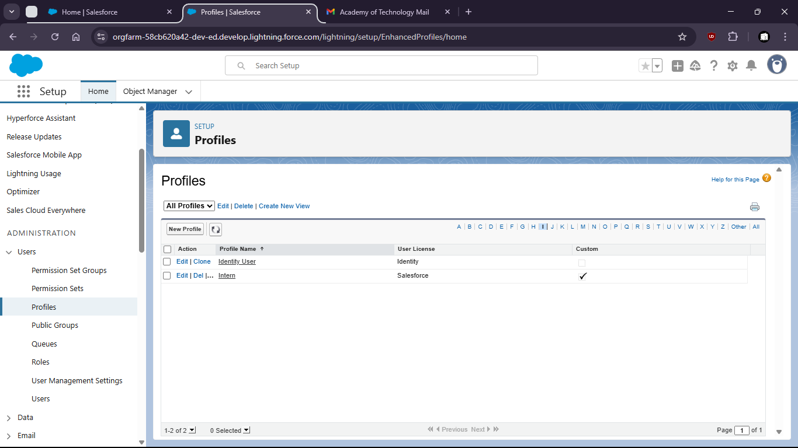Find Intern Profile
3. 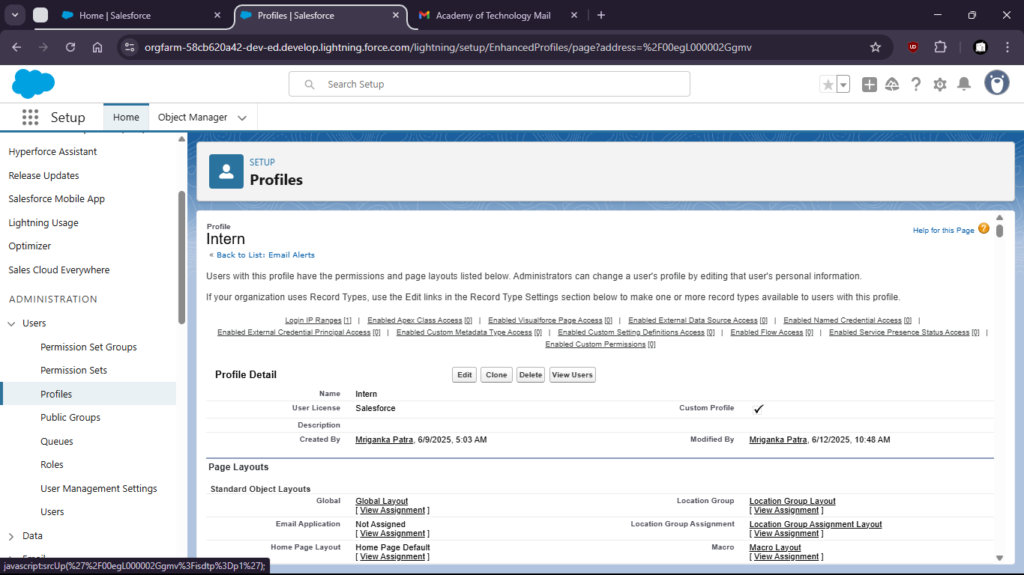
4. Goto field level security and select account
5. 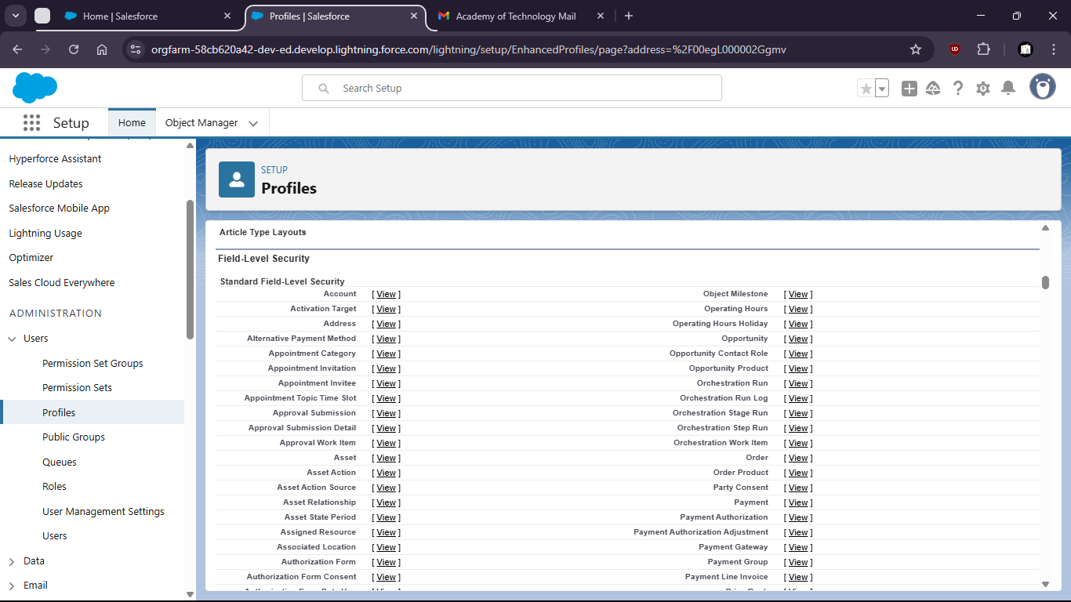
6. Edit annual revenue field
7. 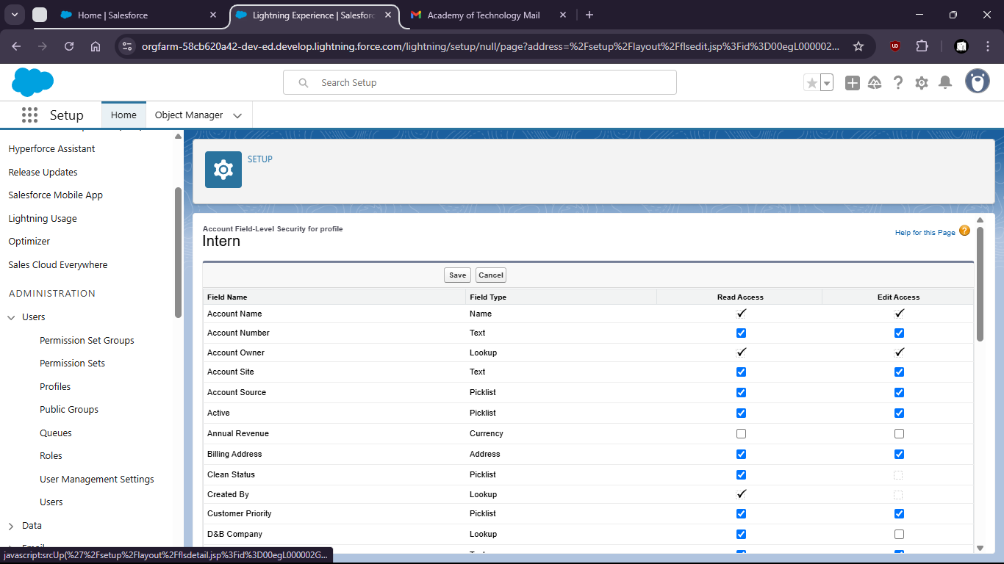
8. Save
9. 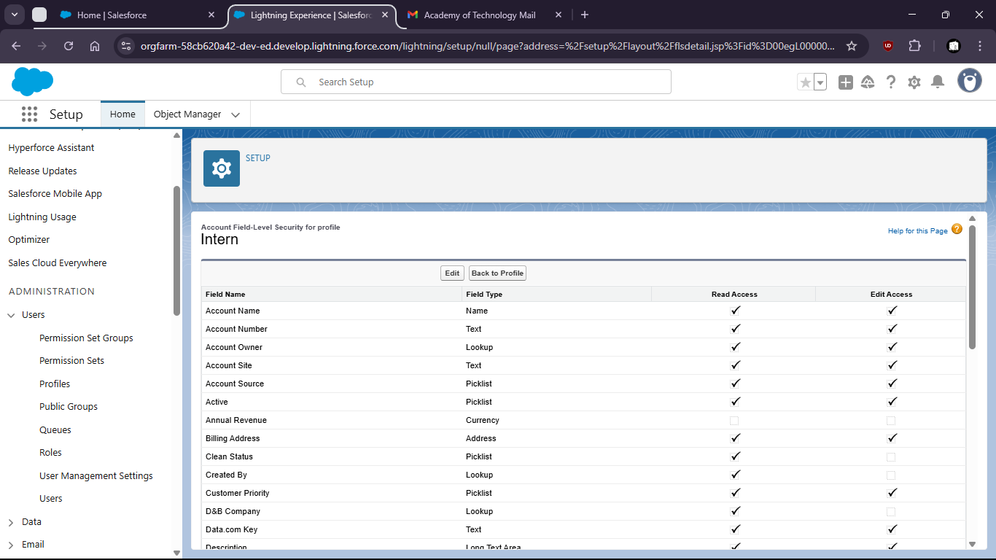

Task 4:

1. Search and open ‘Reports’ from the App Launcher
2. 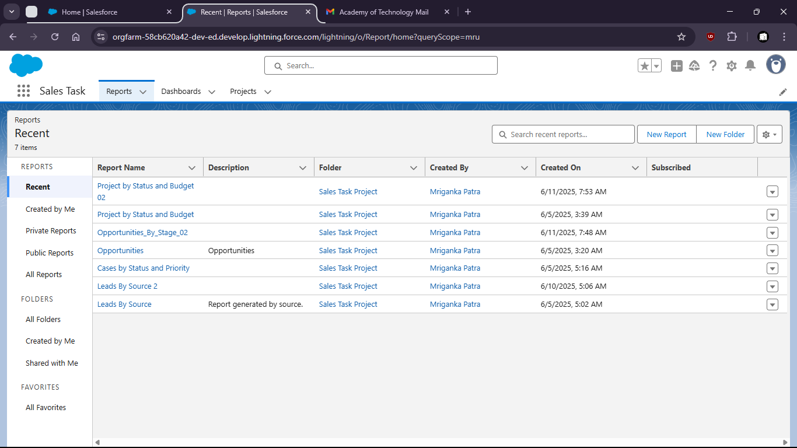
3. Click on New Report
4. 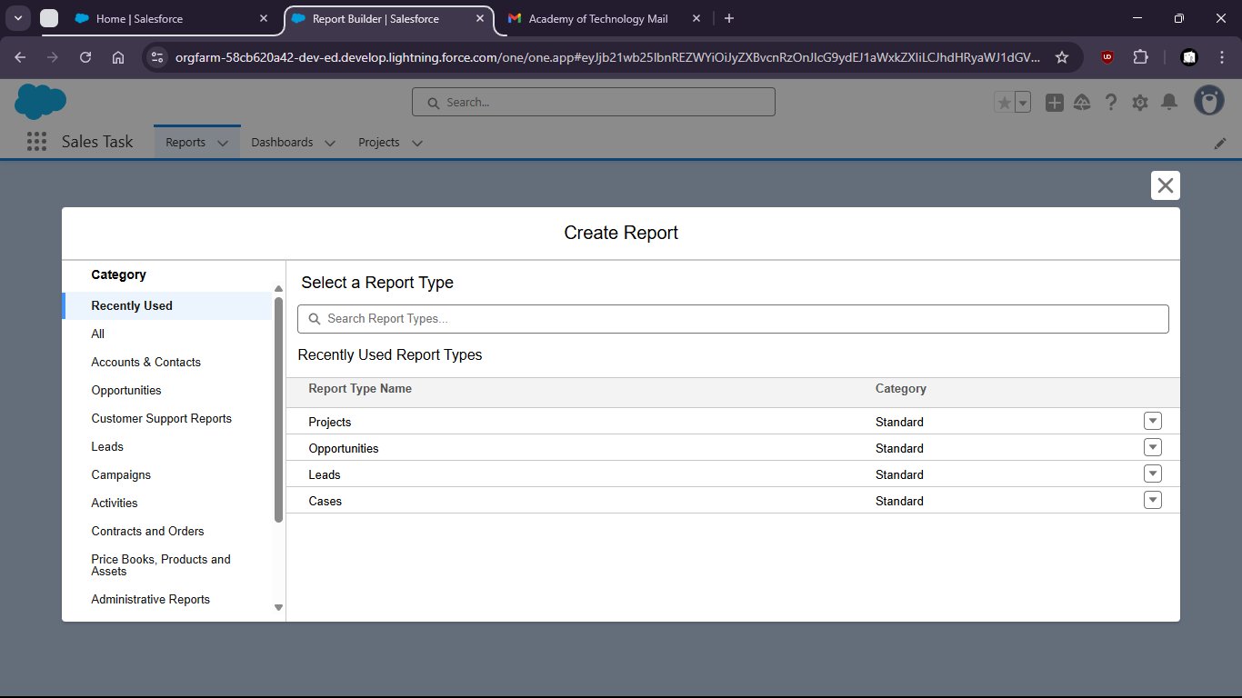
5. Click on Campaigns with Leads and ‘Start Report’
6. 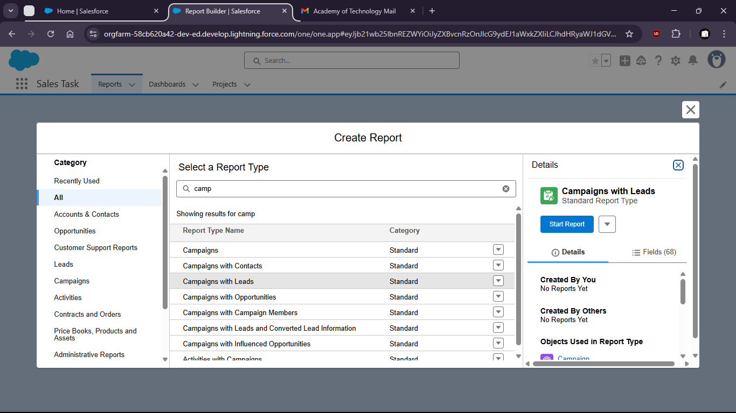
7. Group by Campaign name and create report
8. 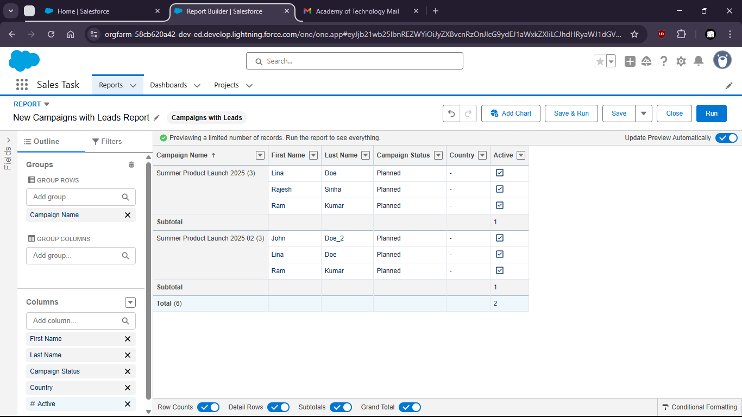

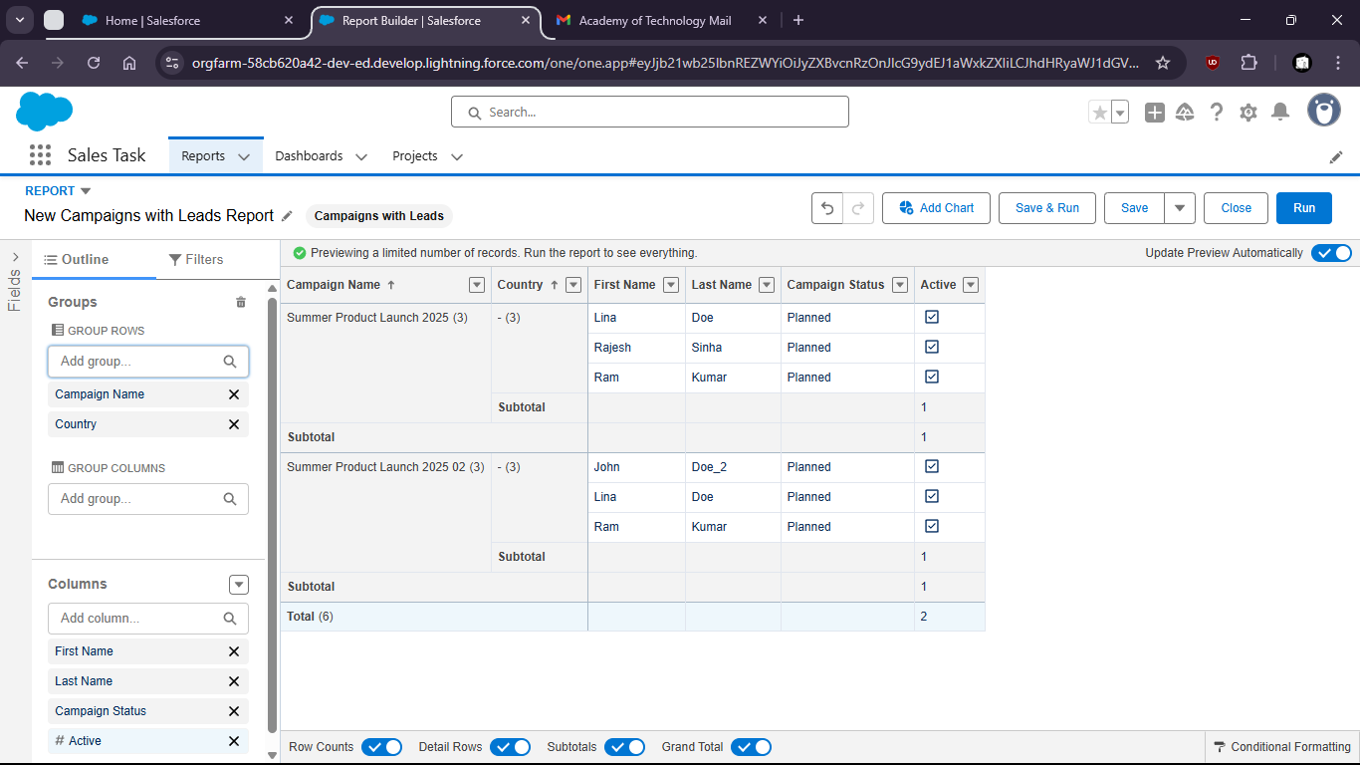

-- Opportunity pipeline grouped by Stage

2. 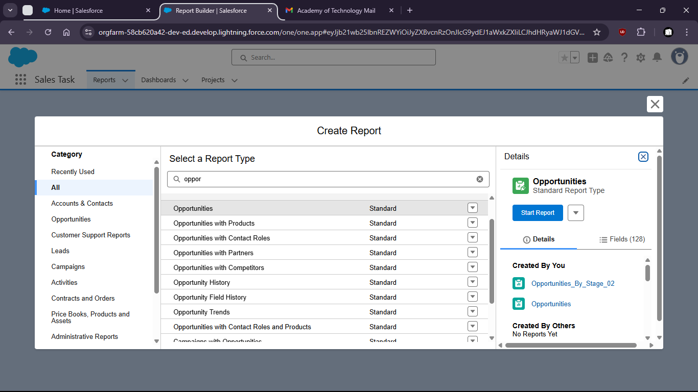
3. 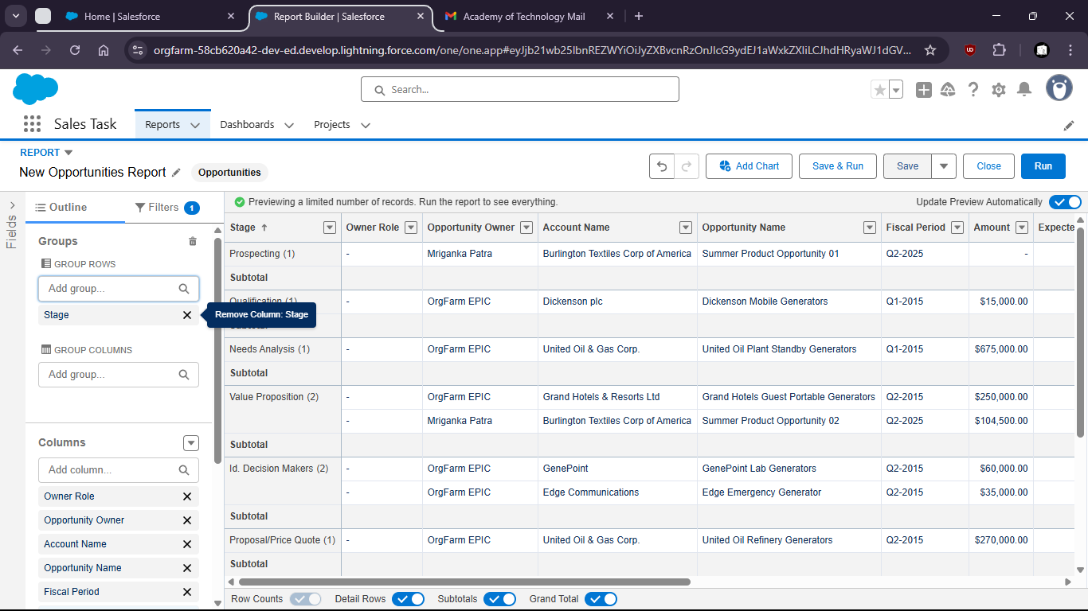
4. 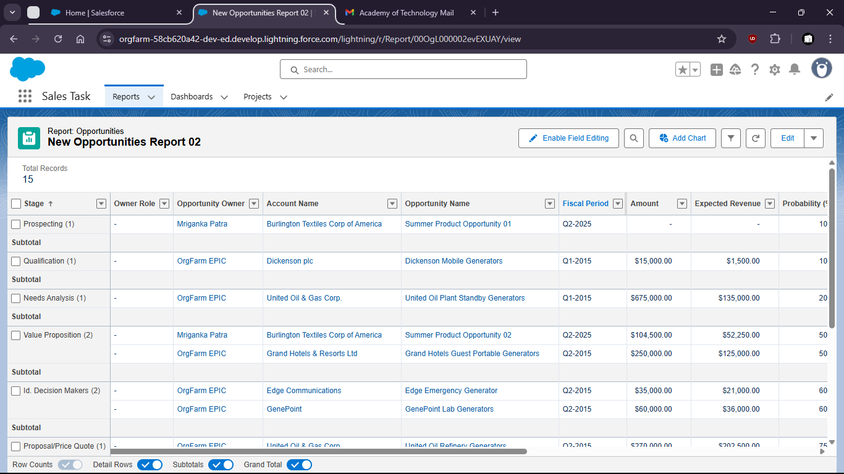

Task 5: Build a dashboard from the above reports and share it with a public group

1. Go to Dashboard and create a new dashboard
2. 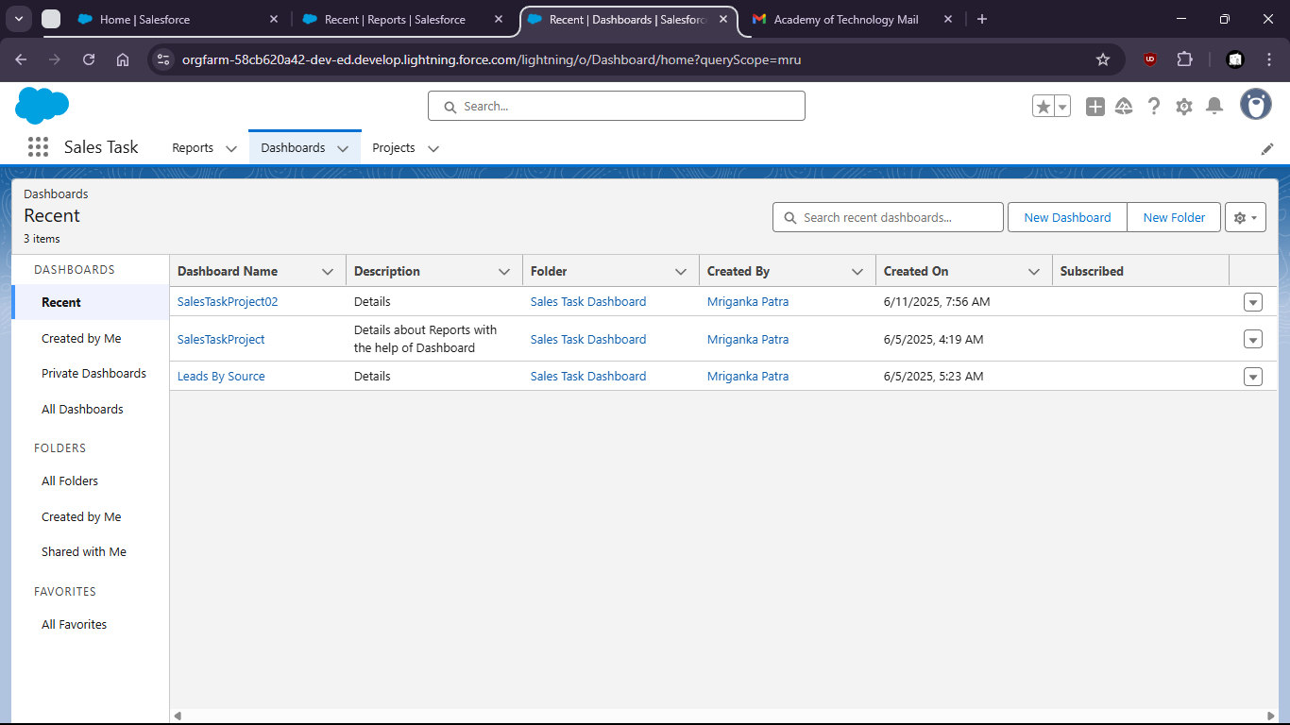
3. 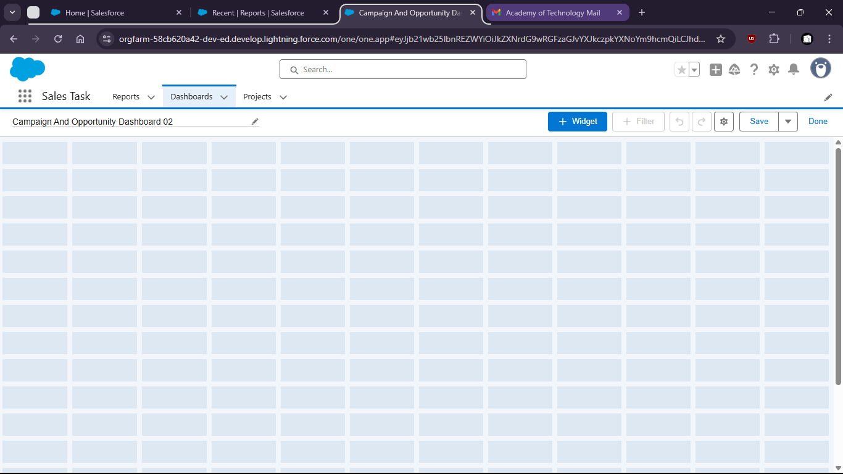
4. Click on Widget
5. 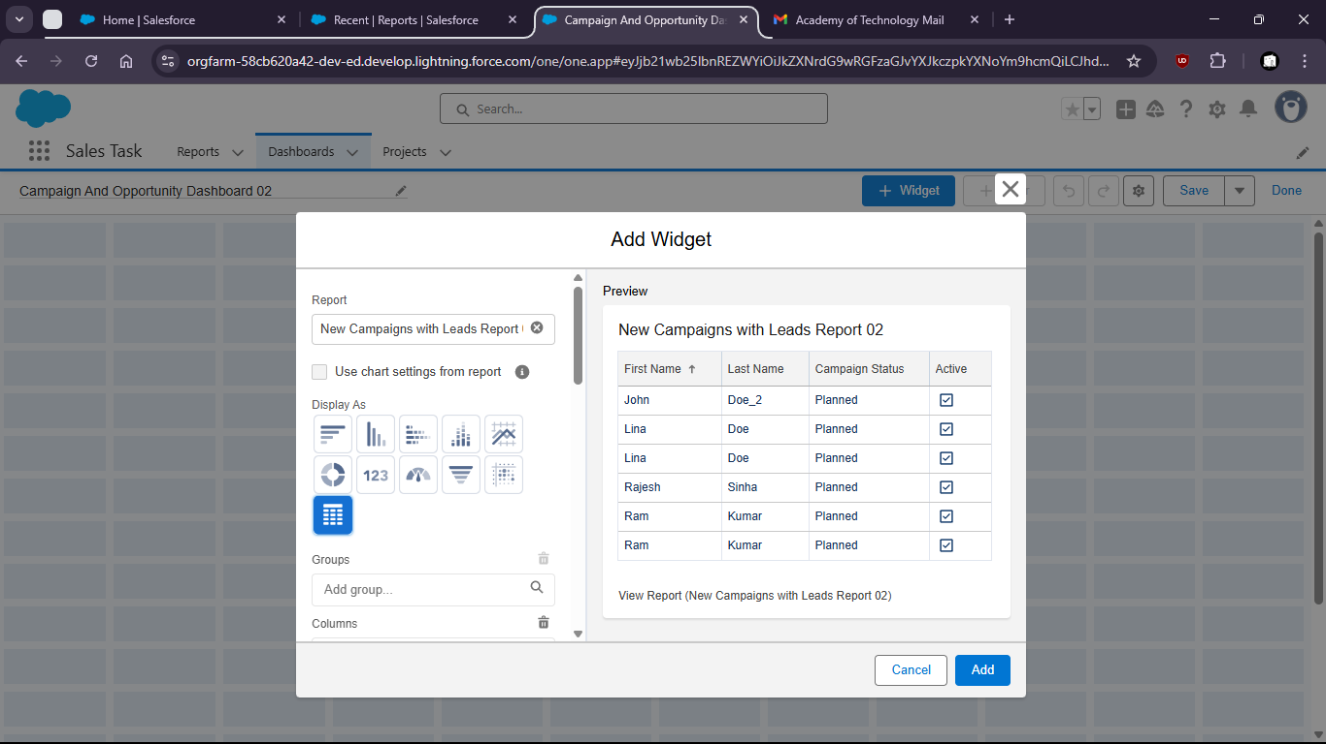
6. Select New Campaigns with Leads Report and Opportunity by stage
7. 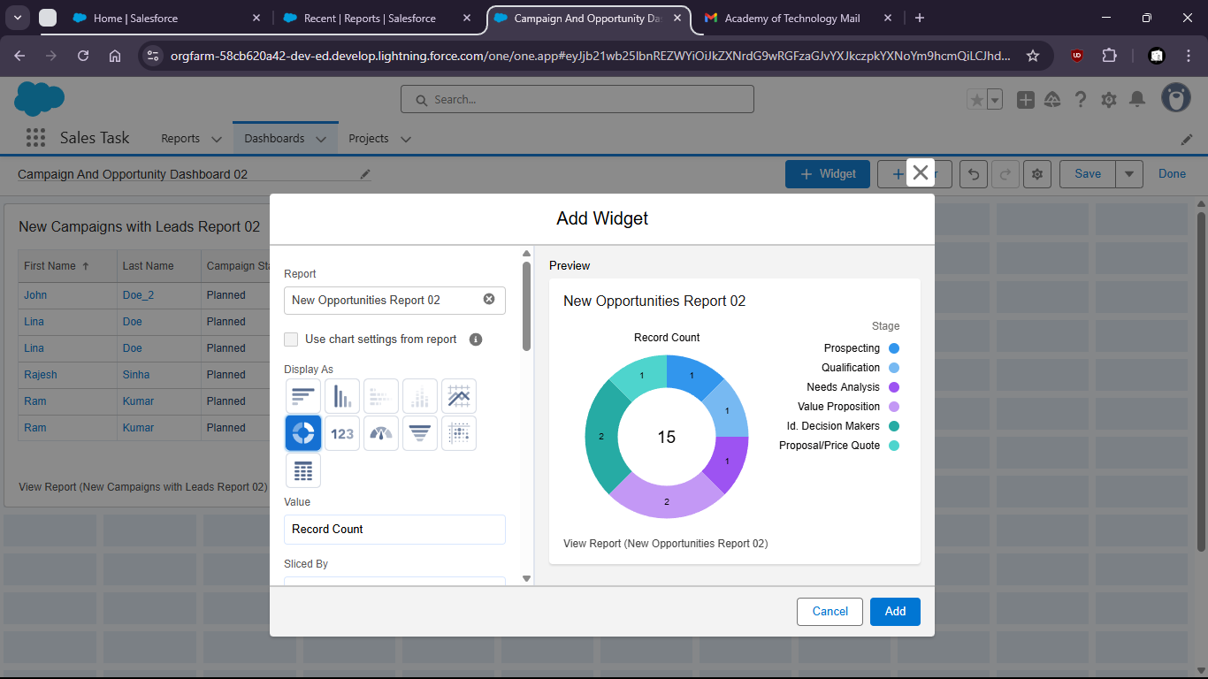
8. 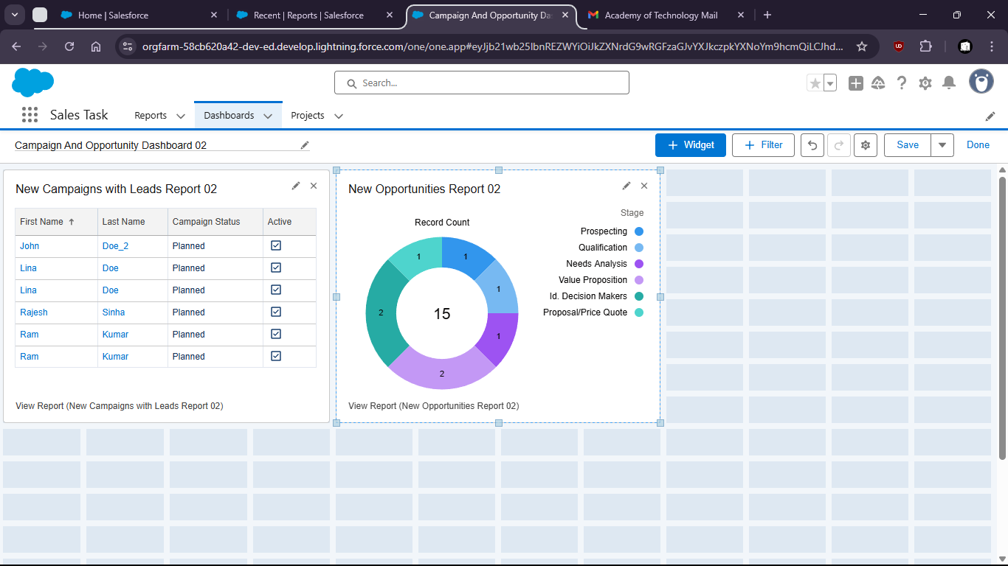

Task 6:

1. Go to Quick Find and search for ‘Data import wizard’
2. 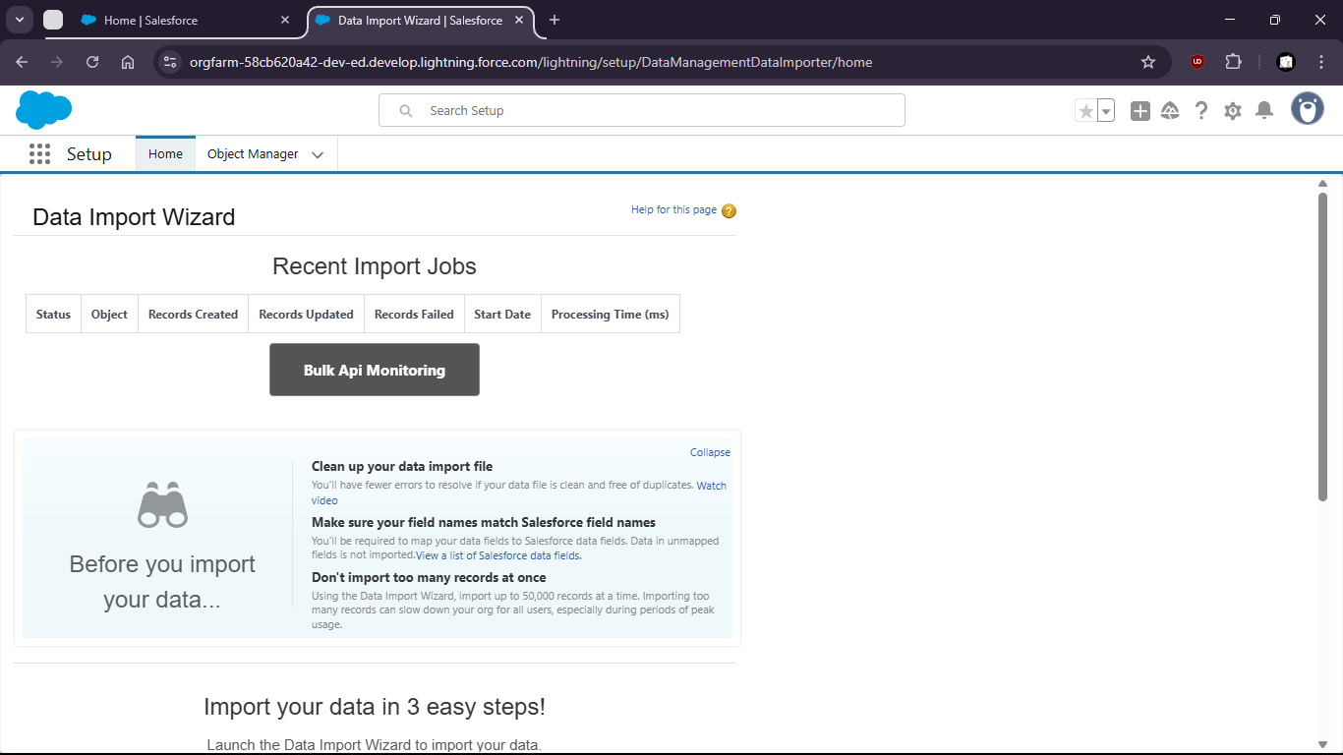
3. Launch the wizard
4. 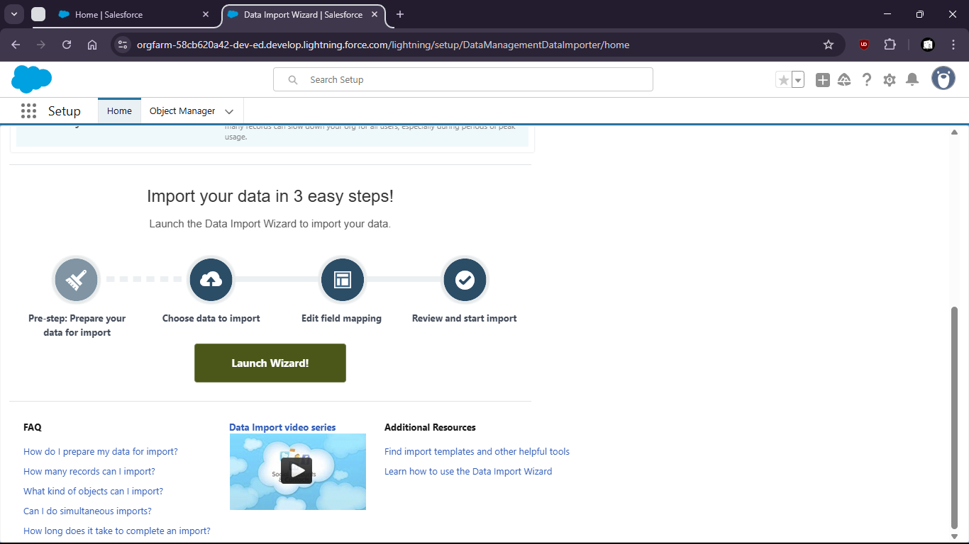
5. Upload the csv file.
6. 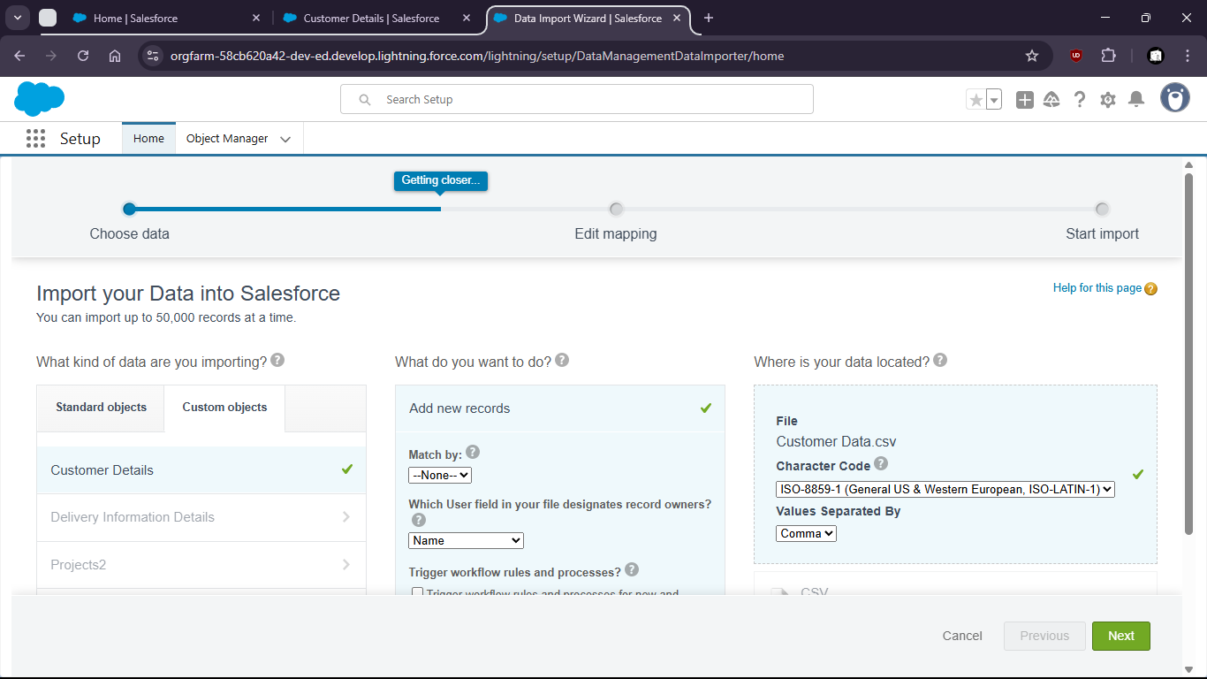
7. . Map the fields
8. 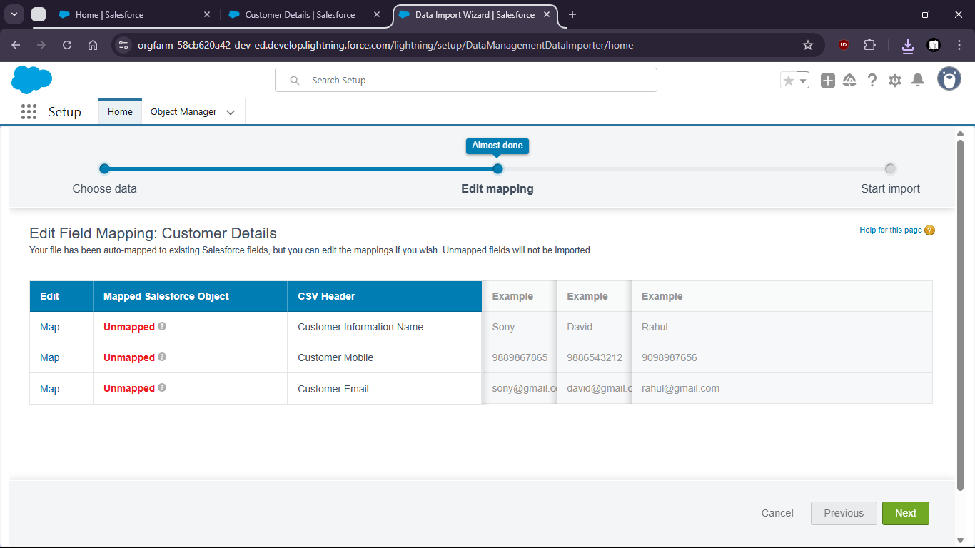
9. 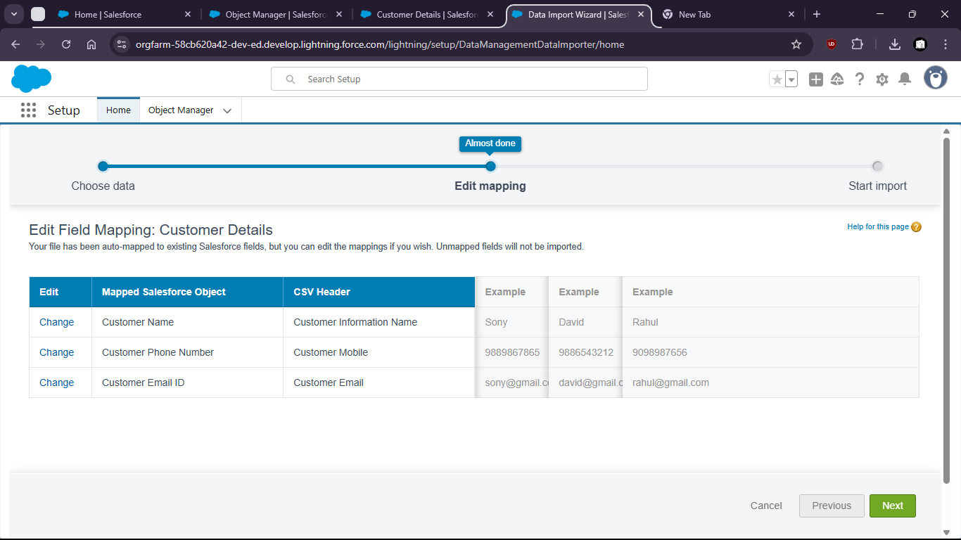
10. Start import.
11. 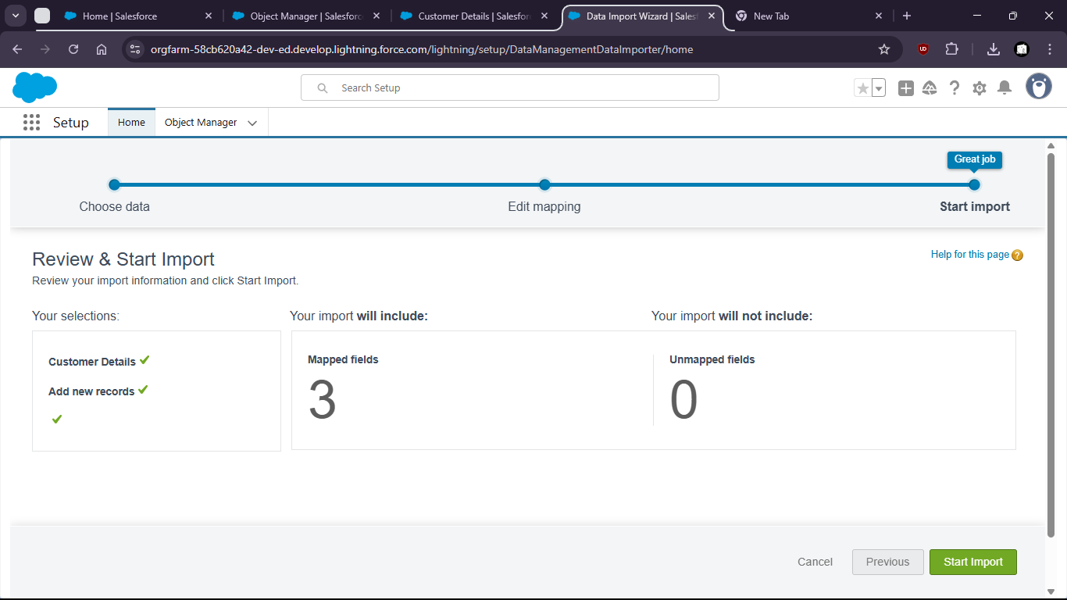
12. 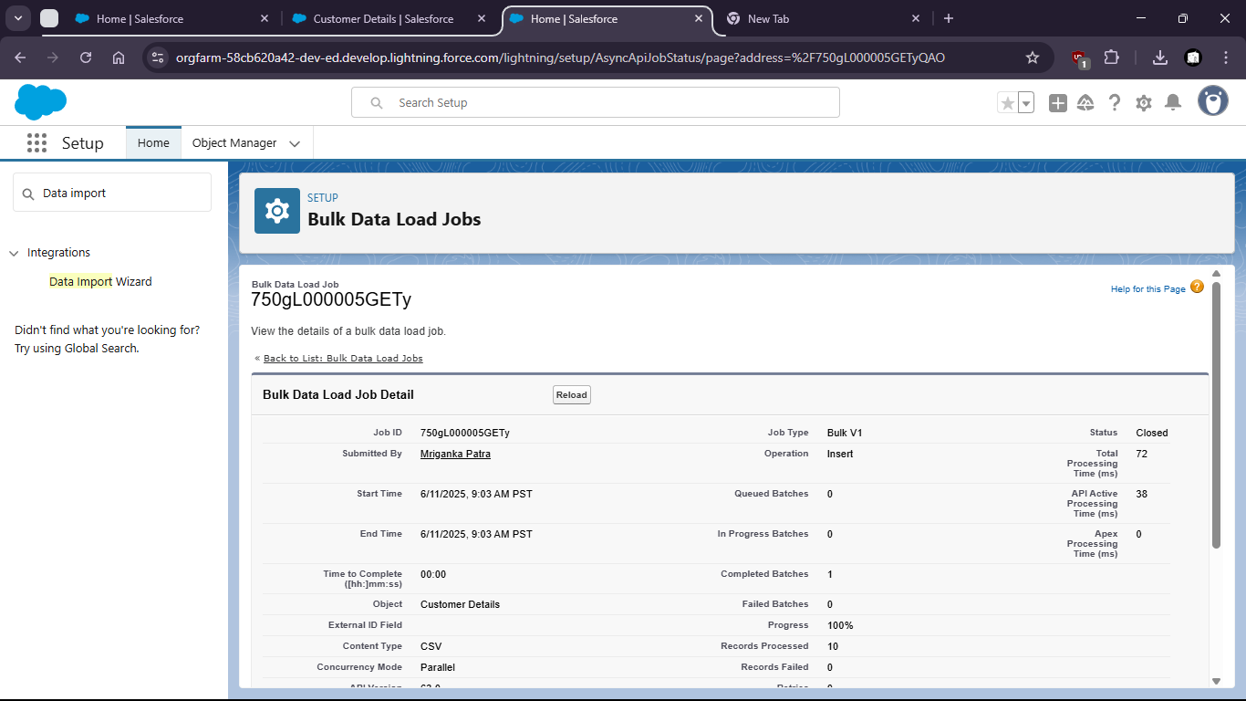
13. 